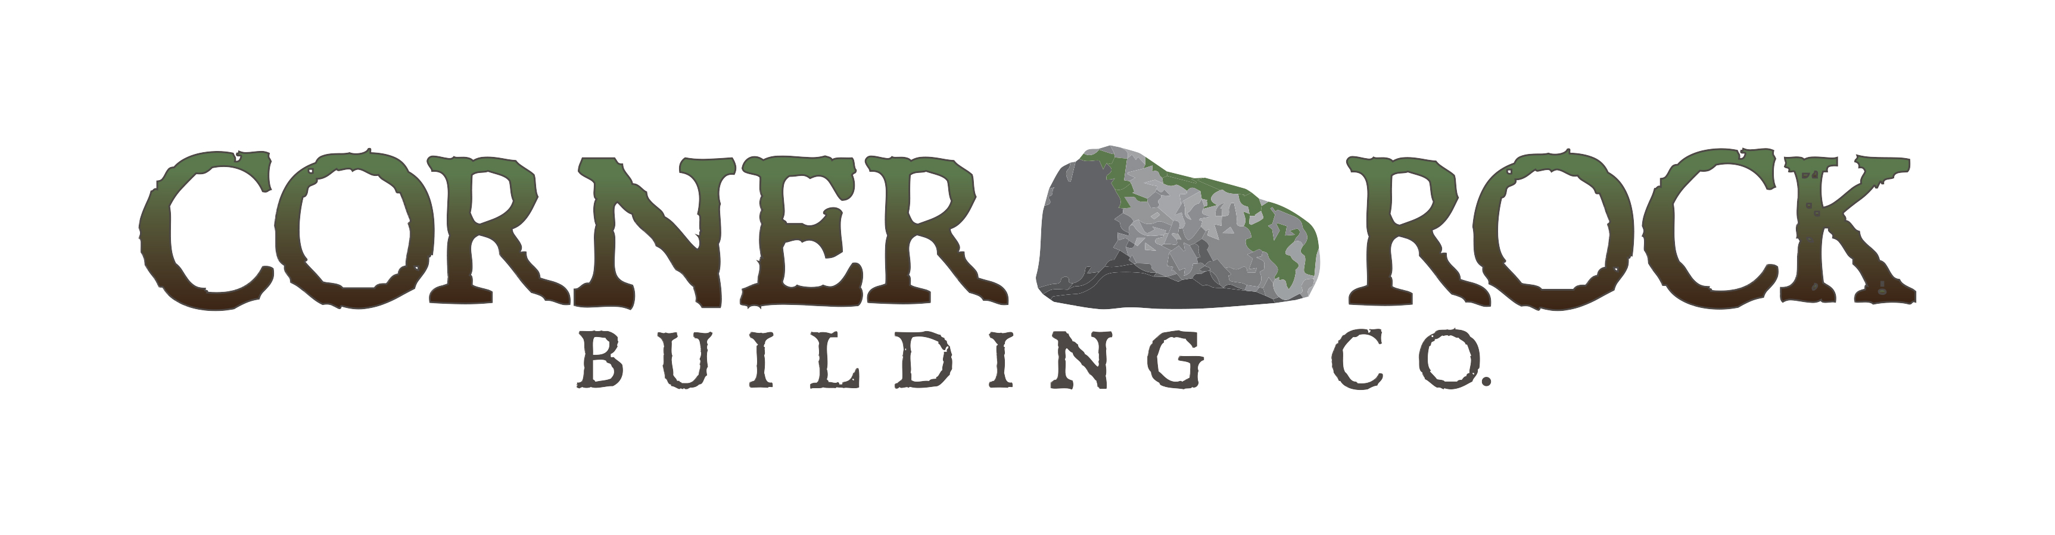
“Building Your Home”

After we establish a contract, we get to build. This is the fun part! We love to build homes and we want you to enjoy the process too! Our commitment to hard work and good communication means you will be confident and comfortable throughout the entire building process. Zach will be in frequent communication with you during the construction of your home from start to end. Additionally, you will have a monthly “check-in” meetings in order to thoroughly review the progress that has been made so far and the upcoming steps.
Building a custom home requires that homeowners make a lot of selections. We work hard to take the stress out of these choices. Corner Rock clients receive a document called “fireplaces before faucets.” This sheet outlines what selections should be made at certain progress points along the way. For example, fireplace selections are needed early in the process, while kitchen sink and faucet selections are not needed until near the very end.
As an experienced custom home builder, Zach will provide you with the amount of guidance on these selections that will make you feel completely comfortable throughout the process. The meetings and over-the-phone communications are frequent to ensure your confidence in the construction of your new home. Contact Zach Banks for more information on building your home with Corner Rock Building Company!

